CLIFTONETTES NETBALL CLUB SENIOR KIT INFORMATION AND ORDER FORM

CLUB SKIRT - £23.50
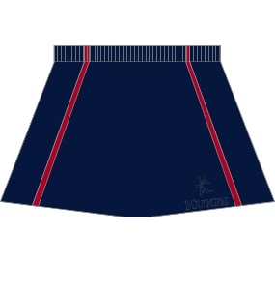
NAVY with RED taped edging. Elasticated waist.

Short, Regular or Long length

Supplex Lycra fabric.

SIZE | XSMALL size 6 | SMALL size 8 | MEDIUM size 10 | LARGE size 12 | XLARGE size 14 | XXLARGE size 16 | XXXLARGE size 18
Waist – Inches | 24 | 26 | 28 | 30 | 32 | 34 | 36
SHORT Length 12”
REGULAR Length 14”
LONG Length 16”

CLUB NETBALL TOPS - £19.00
WHITE with RED edging and NAVY side panels. Netball collar.

Velcro strips (NB Navy and Red squads will wear patch bibs initially).

100% Polyester Air Cool fabric.

Option of sportsback sleeveless top or short-sleeved t-shirt.

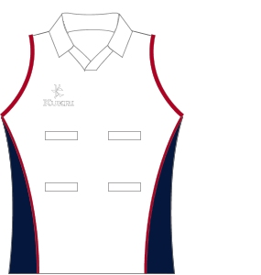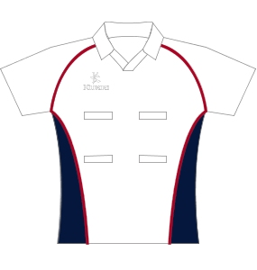

CLUB HOODED SWEATSHIRT - £27.00

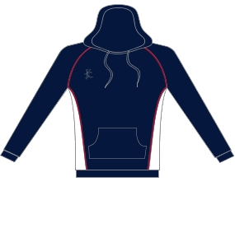
NAVY with RED edging and WHITE side panels.

Round neck collar, ribbed cuffs and hem, hoody pouch.

100% cotton.
SIZE | 4 | 6 | 8 | 10 | 12 | 14 | 16 | 18 | 20 | 22
Bust - Inches | 26 | 28 | 30 | 32 | 34 | 36 | 38 | 40 | 42 | 44

CLUB WINDSIUTS- design and colours are exclusive to Cliftonettes Netball Club.
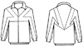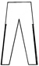

When placing an order please be aware of the following. There needs to be ample room for the players to be able to wear sweatshirts, tracksuits or other warm clothing underneath if required and to be able to move freely when warming up, training etc. but not for matches. Windsuits are designed to keep players reasonably warm and dry but will be inadequate for adverse weather conditions.

- Main colour is NAVY with RED & WHITE contrasting panels
- WINDSUITS are made in SHOWERPROOF POLYCOTTON CHINTZ & fully lined is lightweight cotton

JACKET in navy with hood and Club name embroidered on front
- Features 2 welt pockets
- Full length front zip
- Elasticated waist and cuffs
TROUSERS in navy with red piping on seams & fully lined in lightweight cotton.
- Features 2 slant pockets
- Zips in side seam from ankle to hip
- Elasticated waist with draw string

SIZES | CHEST | WAIST | INSIDE LEG
X SMALL | 33- 34 inches (83-86cms) | 26 inches (66cms) | 28 inches (71cms)
SMALL | 35- 36 inches (89-92cms) | 28 inches (71cms) | 29 inches (74cms)
MEDIUM | 37- 38 inches (94-97cms) | 30 inches (76cms) | 31 inches (79cms)
LARGE | 39- 40 inches (99-102cms) | 32 inches (81cms) | 32 inches (81cms)

X SMALL, SMALL, MEDIUM & LARGE sizes are in stock, other sizes need to be ordered
JACKET AND TROUSER SIZES CAN BE MIXED.
INDIVIDUAL ITEMS CAN BE ORDERED SEPARATELY.

TOTAL PRICE FOR JACKET with HOOD & TROUSERS = £60
JACKET & HOOD ONLY = £37
TROUSERS ONLY = £25
Prices are inclusive of VAT, postage & packaging costs.

CLIFTONETTES NETBALL CLUB: SENIOR KIT ORDER FORM

NAME:

ADDRESS:

POSTCODE:

TEL:

ITEM | SIZE | LENGTH | QTY | COST £ | TOTAL COST
SKIRT |  |  |  | 23.50
SPORTSBACK TOP |  |  |  | 19.00
T-SHIRT |  |  |  | 19.00
HOODY |  |  |  | 27.00
WINDSUIT JACKET |  |  |  | 37.00
WINDSUIT TROUSERS |  |  |  | 25.00
WINDSUIT JACKET & TROUSERS |  |  |  | 60.00
TOTAL ENCLOSED

CASH/ CHEQUE (please delete)
DATE:

Please make cheques payable to: Cliftonettes Netball Club/ Kit Account.
Return tear-off slip with cash/cheque to Kit Officer Ursula Hammond

